Purpose / Scope:
Project Managers run engineering changes (ECR) end to end in PLM2 as a simulation, before the go-live on 12/21/2026. The instruction shows how to play every department with the admin picker ("Act as"), how to start both types of change, how to run the timing, and how to check the Process Flow page against what the system really does. Every bug, missing function or wrong text goes into the findings log, so that it is fixed before go-live. Simulation window 10/05/2026 to 10/16/2026; findings due 10/16/2026.
Owner / involved:
- C. Demmler, Process Development: owner of PLM2 and of this instruction; prepares the test project and accounts, collects and answers every finding
- Project Management: run the simulations in pairs and record every finding in the findings log
- Department members (Sales, Development, Quality, Scheduling, Tool Engineer, APQP): informed that simulations run and that test notifications marked SIM can be ignored
1. Before you start
1.1 What is prepared
No. | Preparation | Status
P1 | Every PLM2 editor signs in through the hub as plm2_Admin, so every tester has the admin picker (sidebar, above "Notifications") | In place
P2 | Test Project (test-project, plant USA Toccoa) holds 13 SIM items: tools 9901 to 9904, molded parts 20-9901-001-0 to 20-9904-002-0 (door trim carrier LH/RH, map pocket LH/RH, grille carrier, bracket 40/60) and the door trim assemblies 10-9901-001-0 / -002-0 with their BOM. All in series, revision 1 | Done 10/01/2026
P3 | Test Project has no project PM on purpose: you set yourself as change lead (step A2). No real person is a department member in PLM2, so SIM tasks and notifications reach nobody else | In place
P4 | Fixes F-01 to F-04 (internal changes), the corrected Process Flow page and the ECR KPI board on the live system. F-06 (ECN check departments) is already live | With the next deployment, before 10/05/2026
P5 | Findings log TOC-PLM-06 ECR Simulation Findings Log.xlsx in the shared folder | Link sent to the testers

1.2 Rules for every simulation
- Work in pairs. The admin picker changes your department, never your person. Steps that need two different people (approving a deviation, PM sign-off plus Quality sign-off) refuse the same account. Person A runs the change, person B approves and signs the second signature.
- Only in Test Project. Never simulate on a real project: the change, its notifications and its deadlines are real records.
- Two impacted items per change. Every impacted item gets its own check workflow at implementation (4 stages, about 18 tasks per item). Two items show everything; four double the clicking.
- Short description starts with SIM and your initials, for example "SIM-CD-1 grille carrier rib change". Then everybody can see it is a test.
- One browser tab per change. The picker is remembered per tab. After opening a new tab, check the purple "Acting as" banner before you click anything.
- Record as you go. Write a finding the moment something is wrong, unclear or slow (section 9). Take a screenshot (Windows: Win+Shift+S) and note the change number and step number.
- Finish or cancel. At the end every SIM change is closed, or cancelled with "Cancel change…" and the reason "Simulation", so that it does not stay in anybody's task list.
This document is the reference for the simulations. You can act without a training sign-off.
2. The admin picker ("Act as")
With the picker an admin works as a member of one department, for example Sales to capture a change and Development to confirm the impact. This lets one person walk a change through every stage.
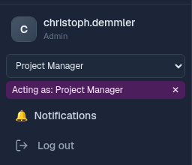
 | How it works
Where | Bottom of the left sidebar, above "Notifications". Only admins see it.
Pick a department | Open the dropdown, choose the department. The page reloads and a purple banner reads "Acting as: <department>".
Back to yourself | Click the ✕ on the banner ("Stop acting as") or choose "Myself (admin)". The page reloads.
What you can pick | Departments only, never a person.
What changes | You have exactly the rights of a member of that department: the admin rights and your own department memberships are switched off, and so are your rights as change lead. "My Tasks" and "Your actions" show what that department owes.
What does not change | You stay the same person. Two-person rules still see you (section 1.2). Notifications to a department reach its real members, not you.
Audit trail | Every action records both: your name and the department you acted as.

2.1 Who does what: the department to pick per step
Step | Act as
Start a customer change, quote deadline, offer, customer answer, publish plan | Sales
Start a change from KTX Weissenburg / Solingen | Project Manager
Pick the change lead (Status card "Pick a lead"), scoping meeting, close assessment / costing, PM sign-off, internal approval, release, close | Project Manager
Priority (only the change lead sets it) | Myself (admin): acting drops the lead right
Pick and confirm the impacted items ("Confirm impact (Development)") | Development (no admin shortcut)
Assessment, cost input, timing confirmation of a department | That department (each R or A department)
Part weight estimate (costing) and measured weight (validation) | Tool Engineer
Quality sign-off | Quality (person B, the PM sign-off is person A)
Bank build decision (running change or planned scrap) | Scheduling
Approve a deviation someone else asked for | Person B, as "Myself (admin)"
D1 gate "Technical release?" before implementation | Myself (admin): while acting the D1 tab shows the gates read-only and says so
ECN check tasks at implementation: "Design review" (stage 2) | The other person of the pair: the stage before was decided by you (four eyes)
ECN check stage 3: "Implement tool change" / "Update master data & logistics" | Process Engineer (Tool Engineer accountable) / Scheduling (PM accountable)

3. The two types of engineering change
Changes are started on the Changes page with "New Change Request" (Sales or Project Manager), or with "Start change request" on a part, tool or project page. Under "Who carries the cost?" the form offers the type.
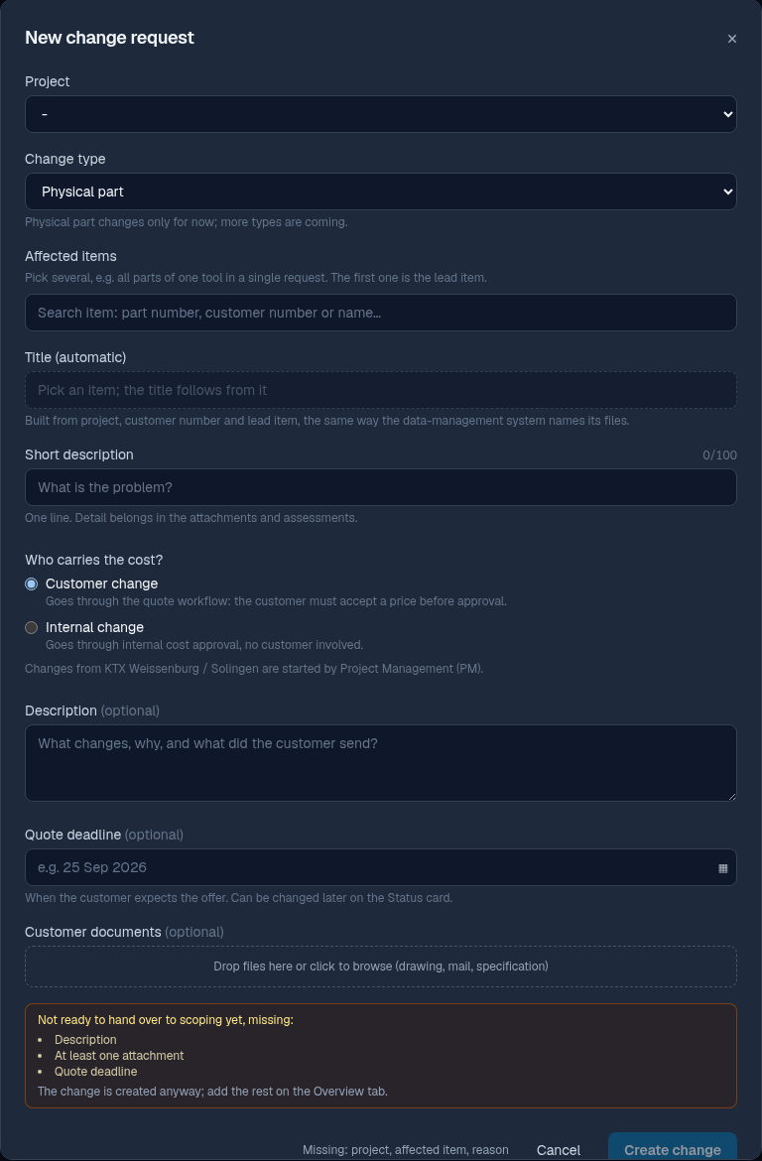
 | Type 1: Customer change | Type 2: Change from KTX Weissenburg / Solingen
Who starts it | Sales or Project Manager | Project Manager only (Sales sees "started by Project Management")
Stages | Captured, Scoping, In assessment, Costing, Quote creation, Quoted, Timing (approved), Implementing, Validation, Released, Closed | Captured, Scoping, Timing (approved), Implementing, Validation, Released, Closed: no assessment, no costing, no offer
Deadline 1 | Quote deadline: when the customer expects the offer (RFQ submission date). Needed before scoping and again before the assessment | none
Deadline 2 | Release deadline: entered with "Customer accepted" | The plant's SOP date becomes the release deadline at approval
Approval | Customer accepted + PM sign-off + Quality sign-off (two different people) | Impacted set locked, the team informed ("Send information to the team"), SOP date set
Timing | Quote plan in the offer, then the detailed plan | Detailed plan from the plant's MS Project file (.xml), or starting from the SOP
Customer | "Publish plan to customer" (Sales) | "Inform <plant>" after validating the timing

Internal change (the plant pays, no customer) is the third choice in the form, switched on 10/01/2026 (F-04). It runs like a customer change up to costing; then the Project Manager approves the internal costs with the release deadline (tab "Approval", "Approve internal costs") instead of an offer. No quote deadline, no offer, no publish to the customer. The scoping meeting can still turn a change internal or customer through the cost carrier. Simulation C1.
4. Simulation A: customer change, start to close
Scenario: the customer asks for an additional rib on a part of Test Project and expects the quote in 10 days. Person A runs it, person B signs Quality and approves deviations. Work through the steps in order; tick each check. The cockpit at the top of the change ("Your actions", "Status", "Blocked by", "Next step") always says what is missing, compare it with this table.
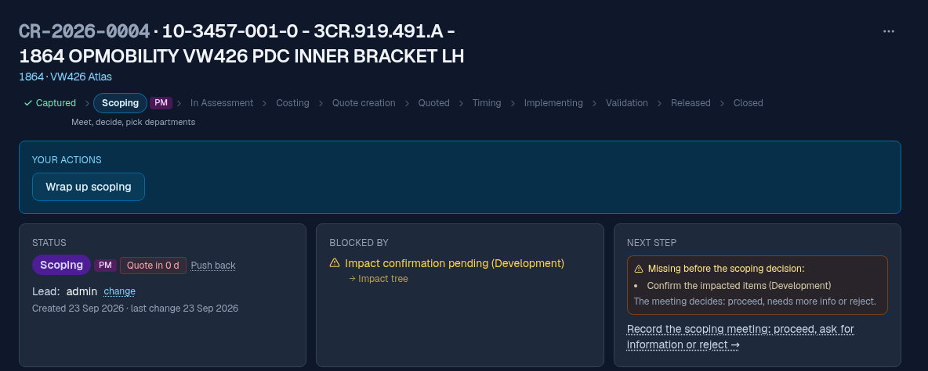
4.1 Capture and scoping
No. | Act as | Where / what you do | Expected result (check)
A1 | Sales | Changes → "New Change Request". Project "test-project · Test Project". Affected items: search and pick 2 parts of the same tool (the first is the lead item). Short description "SIM-<initials>-A additional rib". "Customer change". Description. Quote deadline today + 10 days. Drop one file (any PDF) as customer document. "Create change". | Change CR-… in Captured. Title built automatically from the lead item, e.g. "20-9901-001-0 +1 - SIM.867.011 - SIM DOOR TRIM CARRIER LH". "No lead assigned" (Test Project has no PM). The orange "Not ready…" box was empty before creating
A2 | Project Manager, then Sales | Try "Hand over to scoping" as Sales first. Then, as Project Manager, Status card: "Pick a lead" → yourself. Then, as Sales, "Hand over to scoping" again. | Without a lead the hand-over is refused ("missing change lead before scoping"). With it: status Scoping, stage owner PM, "Quote in 10 d" on the Status card
A3 | Myself (admin), then Project Manager | As change lead: "Priority" High (Status card). Then as Project Manager: "Push back" on the quote deadline by 2 days, first without a reason. | Acting as Project Manager the priority is refused: only the lead or an admin sets it. Push back is refused without a reason; with it the reason shows under the chip and on the Audit tab
A4 | Development | Tab "Impacted": the two carriers are listed. The tree suggests the two door trim assemblies: leave them out (rule in 1.2). "Confirm impact (Development)". | "Impact confirmation pending" disappears from "Blocked by"
A5 | Project Manager | Tab "Scoping": "+ Record a meeting". Channel Meeting, date today, participants. Departments: Tool Engineer R, Development A, APQP S, Manufacturing Engineer C, Packaging not involved. Cost carrier "Customer (customer relevant)". "Save meeting". | Meeting listed with the letters
A6 | Project Manager | On the meeting row "Proceed & start assessment" → "Start assessment". | Status In assessment. Tool Engineer and Development get an assessment task in My Tasks

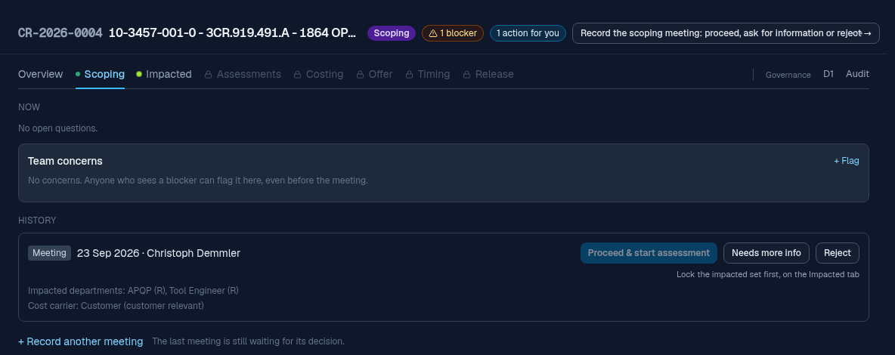
4.2 Assessment and costing
No. | Act as | Where / what you do | Expected result (check)
A7 | Tool Engineer | My Tasks → "Assess". Checklist, verdict "Feasible with conditions", effort 8 h, a condition. "Submit assessment". | Assessment shows submitted; cockpit "Waiting on 1 department"
A8 | Development | Same, verdict "Feasible". In your department's block on the Assessments tab: "+ Flag", kind Risk, with type and severity (risks are raised during the assessment only). | Risk visible in the risk register; it does not block
A9 | Project Manager | "Close assessment". Read the confirm dialog. | Status Costing; dialog lists every verdict and the open risk
A10 | Tool Engineer | Tab "Costing", own block: "+ Activity" 8 h, "Lead time (days)" 15, "Part weight (g)" estimate. One costing position (vendor quote) with an amount. | Block shows Filled; cost summary updates
A11 | Development, APQP | Price their blocks the same way (a department that has no cost enters 0 h with a note). | Header counter of departments still to cost matches the list on the Costing tab (see finding F-01)
A12 | Project Manager | "Close costing". | Status Quote creation (Quoting)

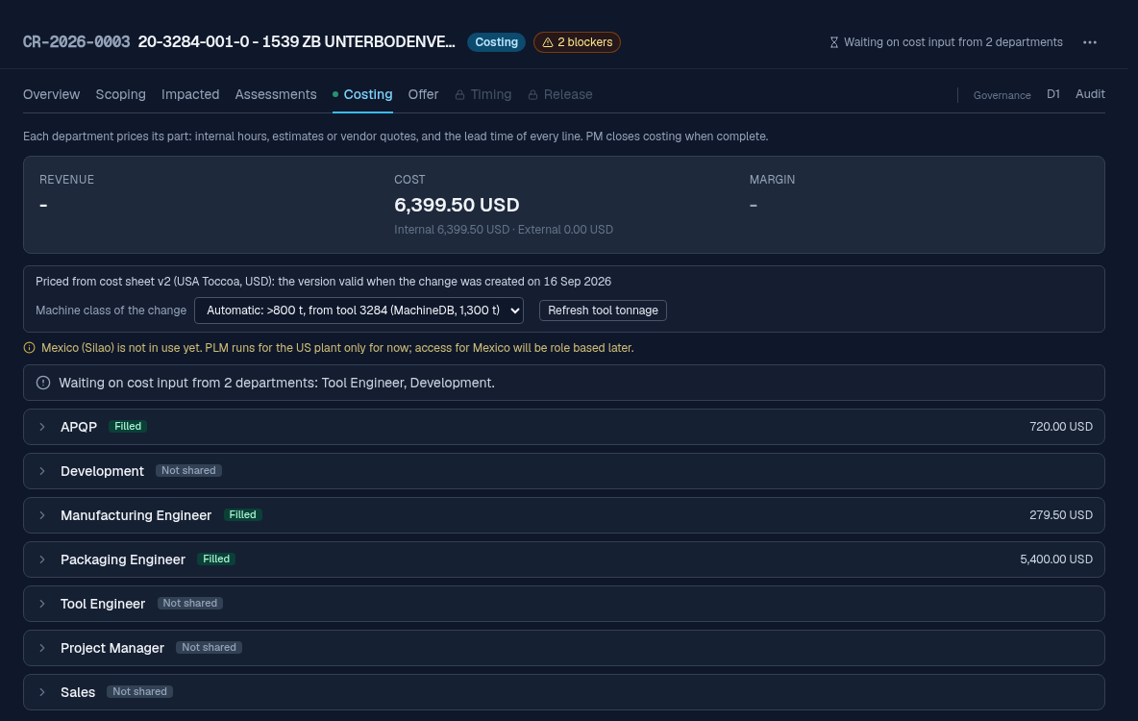
4.3 Offer, customer answer and approval
No. | Act as | Where / what you do | Expected result (check)
A13 | Sales | Tab "Offer": "Start the offer". Timing: the quote plan (section 6.1), "Include in offer". Price, risks, document. "Send offer", "Received by the customer on" today. | Status Quoted. Status card: quoted on time
A14 | Sales | Negotiation: "Customer accepted", Release deadline today + 60 days, "Confirm acceptance". | Status card switches from the quote deadline to the release deadline
A15 | Project Manager (A) | "PM sign-off". | PM sign-off ✓
A16 | Quality (B) | "Quality sign-off". Test first: person A acting as Quality must be refused. | A refused with a clear message; B accepted
A17 | Project Manager | "Record approval". | Status Timing (approved); Timing tab unlocked

4.4 Timing, implementation, validation, release
No. | Act as | Where / what you do | Expected result (check)
A18 | PM / departments | Detailed plan, team confirmation and "Validate timing" as in section 6.2. | Timing validated; baseline set
A19 | Scheduling | "Bank build plan": "Running change", plan note, save. | Decision shown
A20 | Sales | "Publish plan to customer". | Published stamp with name and date
A21 | Myself (admin) | Tab "D1" → "Final assessment" → "Technical release?" = Yes. Look at the tab once while acting as a department first. | Gate answered. While acting the gates show read-only with the hint "Stop acting as a department to decide" (F-03)
A22 | Project Manager | "Start implementation". | Status Implementing; revision 1.1 created for each impacted item, each with its check workflow (My Tasks: "View part")
A23 | Project Manager | Move one plan block by 3 days with a reason (section 6.3) and leave the deviation open. | One deviation group: the moved block and every block it pushed, status open. The work goes on
A24 | Development, then the pair | Each revision's check workflow, 4 stages. Stage 1 (Development): on the part page give revision 1.1 its 3D evidence: upload the CAD, or "No geometry change" with a reason; then approve both steps. Stage 2 "Design review" (Development, Quality): the other person. Stage 3 (Manufacturing Engineer, Process Engineer, Project Manager, Quality, Scheduling, Tool Engineer). Stage 4 (Project Manager, Quality). | Without 3D evidence stage 1 refuses: "3D evidence required". The same person on stage 2 is refused (four eyes). Afterwards every revision completed
A25 | Project Manager | "Finish implementation". | Status Validation even with the open deviation of A23; Release tab unlocked
A26 | Tool Engineer, Development | Release tab, validation checks "Pass": Tool Engineer: tool sampled, part measured, measured cycle time (s), "Measured weight (g)" 5 % above the estimate; Development: revision level raised. | "Quote update required…" appears for Sales
A27 | Sales | "Acknowledge" the weight delta with a note. | Note stored with name
A28 | Departments, then Project Manager | Release checklist: each department marks its rows Done or N.a. with a note (Development, Tool Engineer, APQP, Packaging Engineer, Scheduling, Sales; cycle time: changed or unchanged). "+ Add lesson", "Complete lessons step". "Release change". Then lock the deviation (6.3) and release again. | First release refused: "plan deviations still open: lock or escalate them first". After Lock: status Released
A29 | Project Manager | Read the summary (plan against actual, offer against cost), then "Close change". | Status Closed; everything read-only

5. Simulation B: change from KTX Weissenburg / Solingen
Scenario: KTX Weissenburg changed a tool on their side; we take over the change for our parts and follow their timing. Use any MS Project file (.xml) you have, or leave it empty (then the plan starts from the SOP).
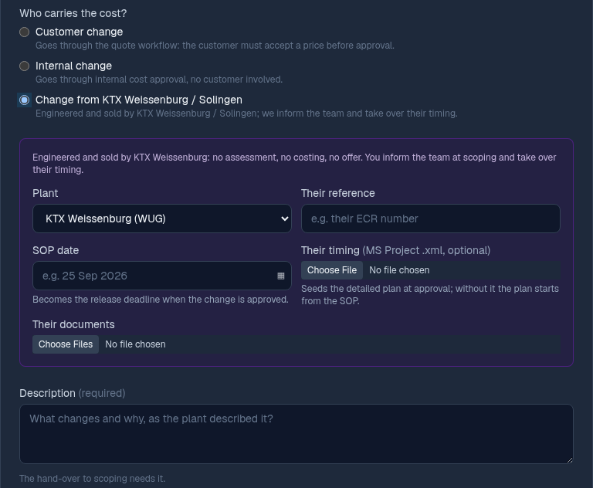
No. | Act as | Where / what you do | Expected result (check)
B1 | Project Manager | "New Change Request", Test Project, 1 to 2 parts, short description "SIM-<initials>-B …", "Change from KTX Weissenburg / Solingen". Plant WUG, their reference, SOP date today + 45 days, their timing (.xml) and documents, description. "Create change". | Change in Captured; tab "KTX Weissenburg" instead of Assessments / Costing / Offer
B2 | Sales | Try "New Change Request" as Sales. | The plant option is not offered (only PM)
B3 | Project Manager | Status card: "Pick a lead" → yourself, then "Hand over to scoping". | Status Scoping. Without a lead the hand-over is refused ("missing change lead before scoping")
B4 | Development | Impacted: "Apply selection", "Confirm impact (Development)". | Impact confirmed
B5 | Project Manager | Scoping meeting with "Departments to inform" (no RASIC letters, no cost carrier). | Meeting saved
B6 | Project Manager | Tab "KTX Weissenburg": tick the departments, write what each has to do, "Send information to N departments". | Departments get the information task; "Blocked by" clears
B7 | Each informed department | Acknowledge the information (My Tasks). | Receipts shown on the tab
B8 | Project Manager | "Record approval" (cockpit). Read the confirm dialog. | Status Timing (approved). Release deadline = SOP date. Detailed plan seeded from their file
B9 | PM / departments | Timing as in section 6.2 (confirmation by informed departments + Scheduling), then "Inform KTX Weissenburg". | Inform stamp; no "Publish to customer"
B10 |  | Implementation, validation, release, close as A21 to A29. | Same as Simulation A

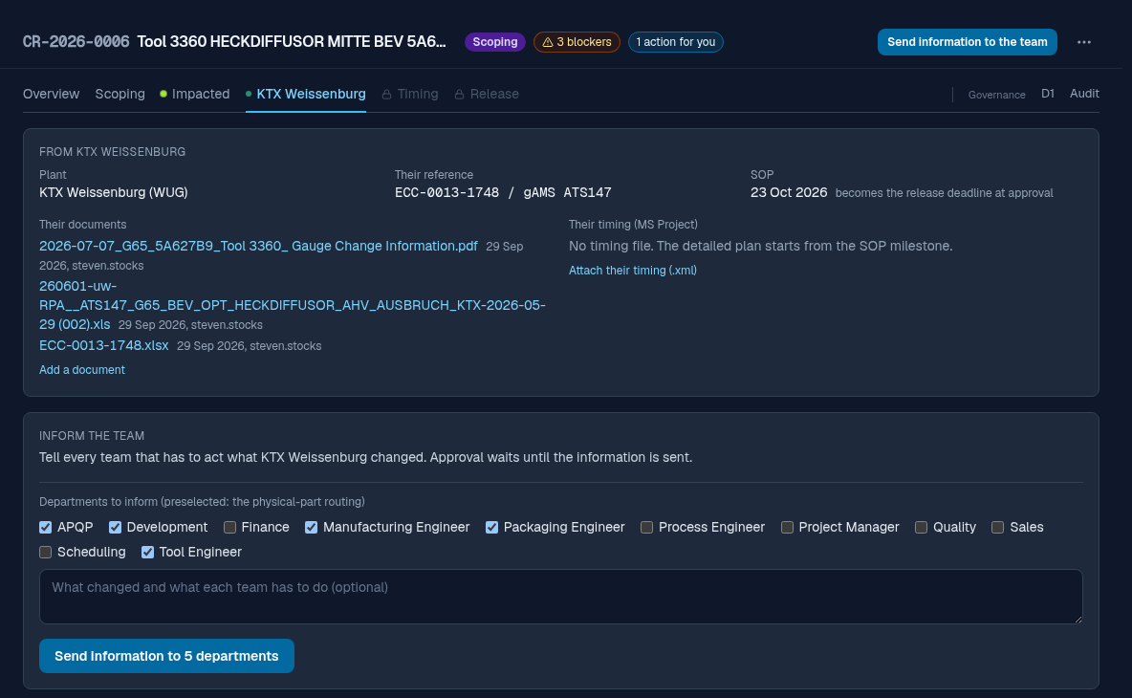
6. Timing in detail
6.1 Quote plan (customer change, from costing until the customer accepts)
- Offer tab, section "Timing". An empty plan offers "Seed from costing" (takes every department's lead time and hours), "+ Add a task" or "Import MS Project".
- Toolbar: "+ Buffer", "+ Bank build idea", "Align", "Lanes". Menu "More": "Auto-schedule now", "Calendar…", "Open in new window", "Seed again from costing".
- "Plan calendar": working days or calendar days, holidays, automatic scheduling. Check that a block over a weekend gets longer in working-day mode.
- An offer that includes timing cannot be sent while the plan is empty or shows errors.
- Check: "Weeks from order" in the offer matches the end of the plan.
6.2 Detailed plan (after approval)
No. | Act as | Where / what you do | Expected result (check)
T1 | Project Manager | Tab "Timing": "Create detailed plan from quote plan". | Every block of the quote plan copied, links included
T2 | Project Manager | Refine: real durations, owners, links. "Open in new window" and edit there. | Main window follows the pop-out without reload
T3 | Every department in the panel | "Team confirmation" → "Confirm timing" for every department the panel lists (here Development, Tool Engineer, Project Manager, Sales, Scheduling). One of them: "Raise concern" with a note. | Counter "n of m confirmed"; the concern blocks validation
T4 | Project Manager | Fix the plan for the concern, ask again; that department confirms. | Earlier confirmations marked "Plan changed after this confirmation"
T5 | Everyone stale | Confirm the current plan again. | All current
T6 | Project Manager | "Validate timing". Before: try it with one confirmation missing. | Refused with the departments still missing; afterwards baseline set. A warning that the plan ends after the release deadline is information, not a block

6.3 After the baseline: tracking and deviations
- Every date move becomes a deviation with reason, slip and effect on the finish. Blocks pushed along by a move form one group and take one decision.
- "Lock" / "Lock all N": accepted internally (no customer impact). "Escalate to customer": Sales tells the customer.
- An open deviation blocks the release. Test it: leave one open, try "Release change" (expected: blocked, "Release with a deviation").
- Moving the release deadline itself: Status card "Move". It asks why, and refuses without a reason (F-02, fixed): it is the date the customer was promised and the KPI "implemented on time" uses it.
- Timing tab buttons "Export to MS Project" and "Export as CSV": open the XML in MS Project and compare.
7. Simulation C: variants (one each, short)
No. | Variant | How | Expected
C1 | Internal change | "New Change Request" → "Internal change" (no quote deadline). After costing, tab "Approval": "Approve internal costs" with the release deadline (Project Manager), then "Record approval". Also try: a customer change turned internal at the scoping meeting. | No quote, no offer; costing goes to approved. Sales is refused the approval
C2 | Needs more info | Scoping meeting decision "Needs more info" with a question. Sales answers with a customer mail. | Sales task "Obtain info from customer"; change stays in scoping
C3 | Not feasible | One department submits "Not feasible" (needs the change PPT). | Cockpit offers "Reject change", "Back to scoping", "Override with a reason"
C4 | Rejection | "Reject change" with reason. Sales "Send rejection letter". | Cannot close without letter; closes after "sent"
C5 | Reopen | On a rejected change "Reopen change" with reason. | Back in scoping
C6 | On hold | "Put on hold" in costing, then "Resume". | Returns to costing only
C7 | Deviation four-eyes | Hand over to scoping without description. "Request deviation" (A); A tries to approve; B approves; A "Retry transition". | A refused, B accepted, transition done
C8 | Late RFQ | Quote deadline yesterday, then send the offer today. | Status card shows the quote deadline overdue (red) before; quoted late after
C9 | Reopen costing | In quoting "Reopen costing" with reason. | Back in costing, numbers editable
C10 | Cancel | "More actions" → "Cancel change…" with reason. | Cancelled, gone from task lists

8. Process Flow check
The Process Flow page (sidebar "Process Flow", views "Detailed" and "Overview") is drawn by hand, not generated from the system. A desk check against the program on 10/01/2026 found 18 differences; the page was corrected the same day (F-05). These are the rules the page now shows and PLM2 enforces (soft = an approved deviation lifts it, hard = nothing lifts it). Keep the page open in a second window during each simulation and confirm every rule you pass in the sheet "Process Flow check" of the findings log: Yes, or what you saw instead.
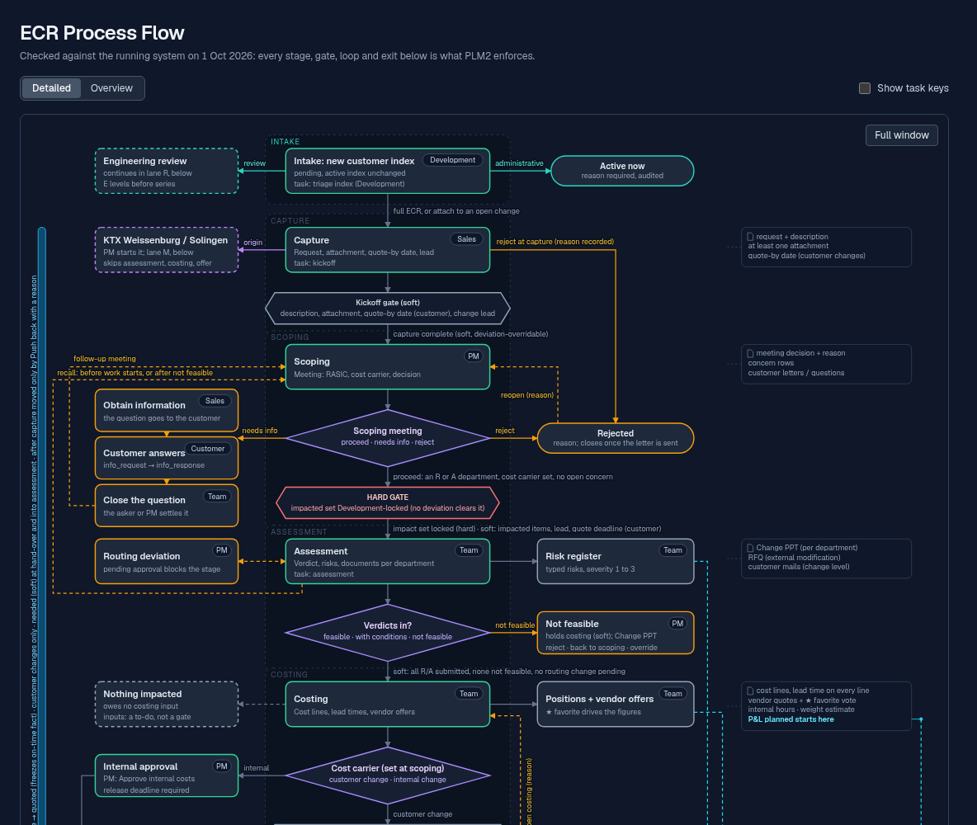
No. | Rule (Process Flow page and system, since 10/01/2026) | Check in
M1 | Hand-over to scoping (soft): description, at least one attachment, quote deadline (customer change) and a change lead | A1-A2
M2 | Into assessment: "Proceed" needs at least one R or A department, no open question or cancel vote, and the cost carrier. Soft: impacted items, lead, quote deadline. Hard: the impacted set confirmed by Development | A4-A6
M3 | The cost carrier is fixed at the scoping meeting and cannot change after scoping | A5, C1
M4 | Into costing (soft): every R/A assessment submitted, no "not feasible", no routing change pending | A9
M5 | "Not feasible" does not reject: it holds costing and offers "Reject change", "Back to scoping" (reason) or "Override with a reason" (four eyes) | C3
M6 | Moves back, each with a reason: reopen costing (from quote creation), reopen a rejected change, back from validation to implementation | C5, C9
M7 | "Customer declined" records the answer only; rejecting is its own step, and a rejected customer change closes only after the rejection letter is attached and marked sent | C4
M8 | Approval of a customer change (hard): customer accepted, PM sign-off and Quality sign-off by two different people; then "Record approval" | A14-A17
M9 | Publishing the plan is not a gate. It needs the validated timing and the bank build decision (running change, or planned scrap with a scrap price) | A19-A20
M10 | Into implementation (soft): timing validated, impact confirmed, a check workflow for every item category, D1 "Technical release?" = Yes | A21-A22
M11 | Into validation (soft): every impacted item has its revision. Open plan deviations do not stop this step | A25
M12 | Release (soft): validation checks passed, no open validation issue, every revision through its check workflow, release checklist complete, lessons step done, no open plan deviation | A28
M13 | Release deadline: set with "Customer accepted" (internal: "Approve internal costs"; Weissenburg / Solingen: their SOP), moved only with a reason | A14, 6.3
M14 | Quote deadline: needed at the hand-over and again into assessment (customer change); after capture only "Push back" with a reason; active until the offer is sent | A1-A3
M15 | On hold: "Resume" goes back to the stage it was held in, nowhere else | C6
M16 | Back to scoping (recall) only while no assessment has started, or after a "not feasible" | C3
M17 | Timing: confirmed by every department in the Team confirmation panel, validated by Sales, PM, Scheduling or the lead; it can be validated again during implementation (new baseline) | T3-T6
M18 | The engineering review lane and the intake are owned by Development | -

9. Recording findings
Every finding goes into TOC-PLM-06 ECR Simulation Findings Log.xlsx, one row each, the same day. Sheet "Findings" for bugs and wishes, sheet "Process Flow check" for M1 to M18.
Column | What to write
Type | Bug (wrong result, error message, crash) · Change (works, but should work differently) · Missing (function needed and not there) · Text (label or message unclear) · Process Flow (page and system differ)
Severity | A blocks go-live (wrong data, a step that cannot be done, a gate that does not hold) · B must be fixed, a workaround exists · C improvement
Where | Simulation and step number (e.g. A16), change number, the department you acted as
What I did / what happened / what I expected | One sentence each. Exact message text in quotes
Screenshot | File name of the screenshot, saved next to the log

Findings due 10/16/2026. Review of all findings with Project Management on 10/20/2026: each gets a decision (fix before go-live, after go-live, no change) and becomes an action in the LOP where needed.
9.1 Already known (check them, add what you see)
No. | Finding | Where
F-01 | Costing: header "Waiting on cost input from 2 departments" while the Costing tab said "4 of 7 departments have not costed yet". Fixed 10/01: both name the departments that still owe an input | A11
F-02 | Release deadline could be moved without a reason. Fixed 10/01: "Move" asks why, the reason is required and audited | 6.3
F-03 | D1 tab showed the gate buttons to an admin acting as a department, then refused. Fixed 10/01: read-only while acting, with a hint | A21
F-04 | "Internal change" was greyed in the start form. Fixed 10/01: internal changes can be started; walked end to end before switching on | C1
F-05 | Process Flow page differed from the system in 18 points. Fixed 10/01: page aligned (section 8) | 8
F-06 | ECN check workflows, stage 3: "Implement tool change" went to Production and "Update master data & logistics" to Logistics, both retired: nobody got these tasks. Fixed 10/01 (live): Process Engineer (Tool Engineer accountable) and Scheduling, along the role remap | A24

10. Help while testing
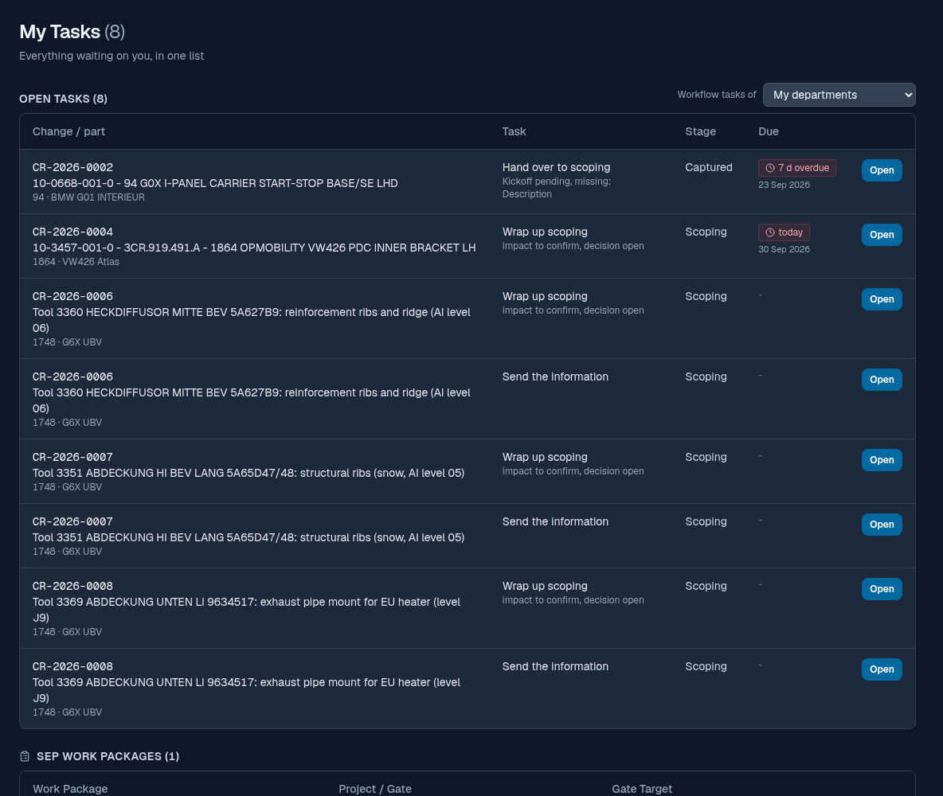
- My Tasks (sidebar) lists everything the department you act as owes, with the button that opens the right tab.
- "Transition blocked" banner: the yellow list says what is missing. Fill it in, or "Request deviation" with a reason; person B approves; then "Retry transition".
- KPI board (Changes → "KPI board"): RFQ and implementation on time. Test Project is left out on purpose, so SIM changes never show there.
- Stuck or unsure: write the finding, note where you stopped, and contact C. Demmler.

